Test Case: tc006_SPX_Dev5_Crear_Requisicion_Spot_Tipo_Cobro_Proyect_Urgent
Step 1 - Enter username and password and click to button Enter: Credentials Entered
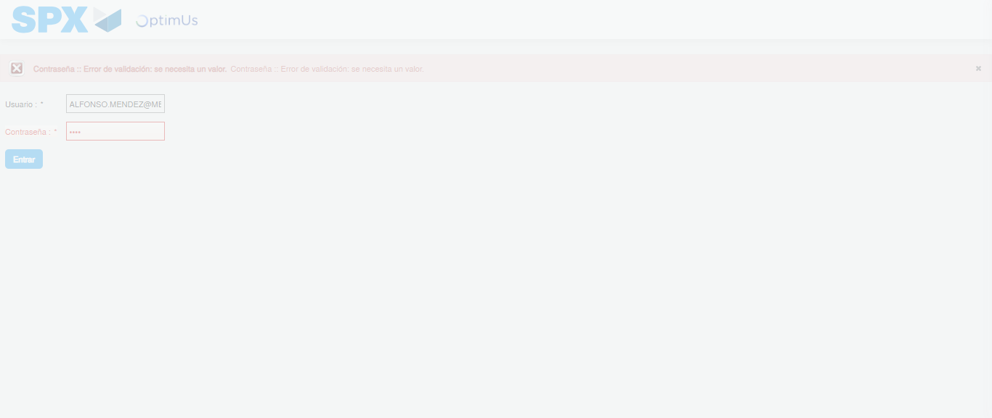Image file-name: QC_Testing-tc006_SPX_Dev5_Crear_Requisicion_Spot_Tipo_Cobro_Proyect_Urgent-1783376576901

Step 2 - Select to UEN and Access to Spot Buy Requisitions : UEN Correctly selected and Correct access
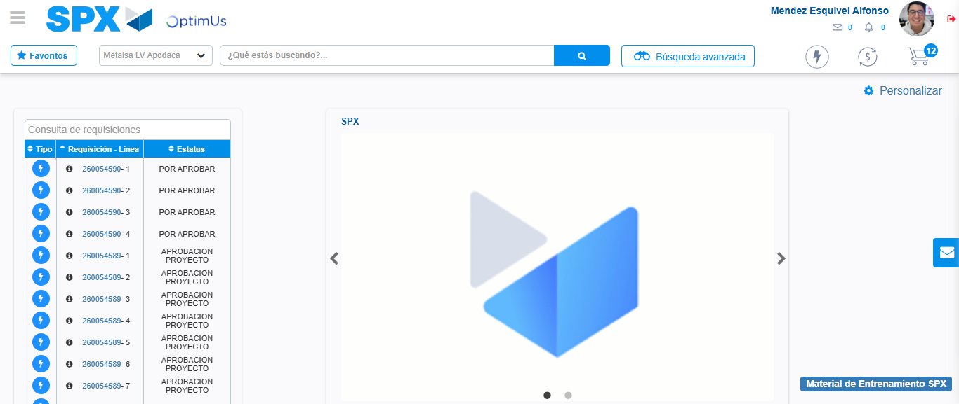Image file-name: QC_Testing-tc006_SPX_Dev5_Crear_Requisicion_Spot_Tipo_Cobro_Proyect_Urgent-1783376603058

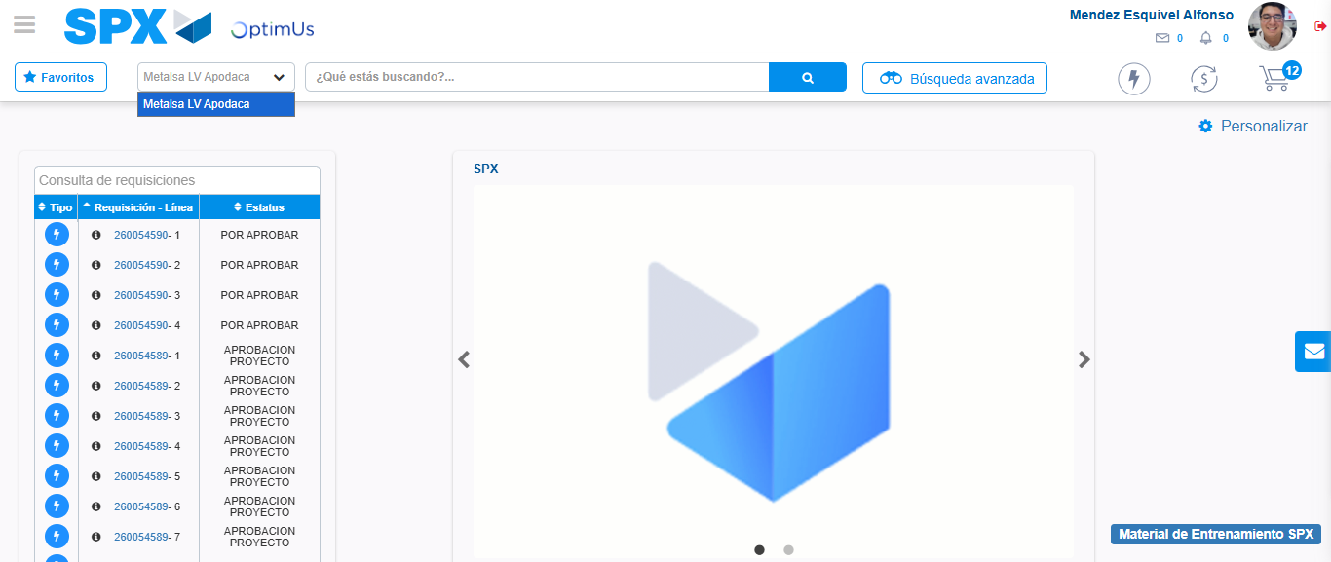Image file-name: QC_Testing-tc006_SPX_Dev5_Crear_Requisicion_Spot_Tipo_Cobro_Proyect_Urgent-1783376605588

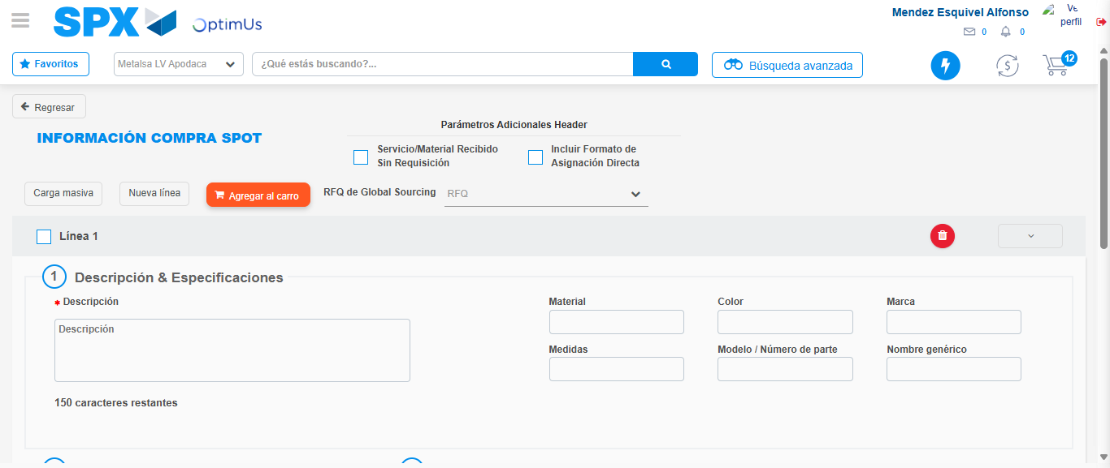Image file-name: QC_Testing-tc006_SPX_Dev5_Crear_Requisicion_Spot_Tipo_Cobro_Proyect_Urgent-1783376622472

Step 3 - Data Capture Spot Buy Requisition: Data captured correctly
Image file-name: QC_Testing-tc006_SPX_Dev5_Crear_Requisicion_Spot_Tipo_Cobro_Proyect_Urgent-1783376622735

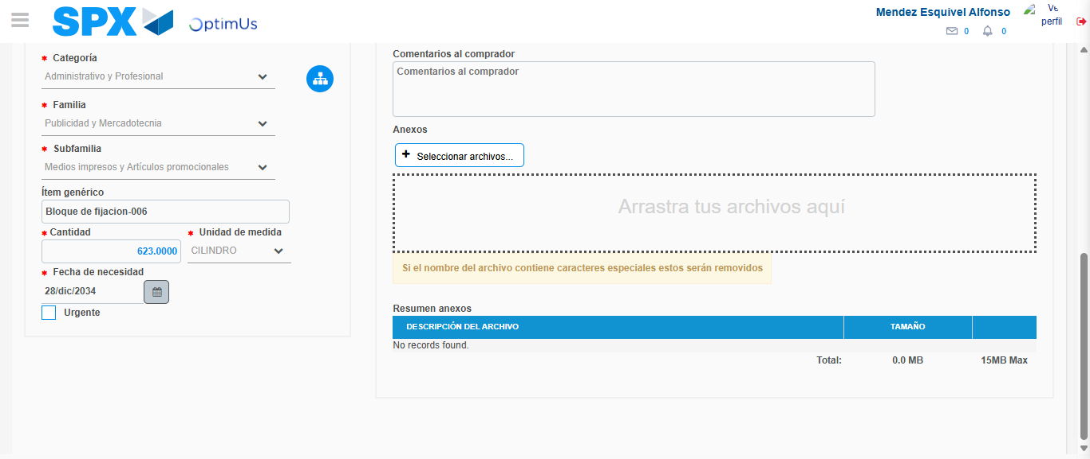Image file-name: QC_Testing-tc006_SPX_Dev5_Crear_Requisicion_Spot_Tipo_Cobro_Proyect_Urgent-1783376633706

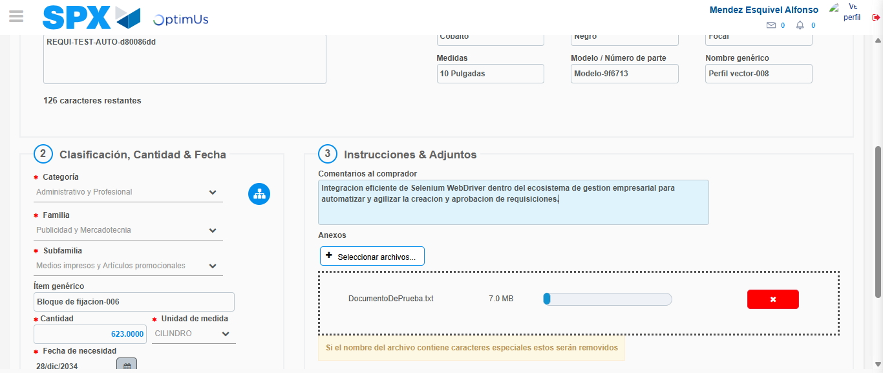Image file-name: QC_Testing-tc006_SPX_Dev5_Crear_Requisicion_Spot_Tipo_Cobro_Proyect_Urgent-1783376634498

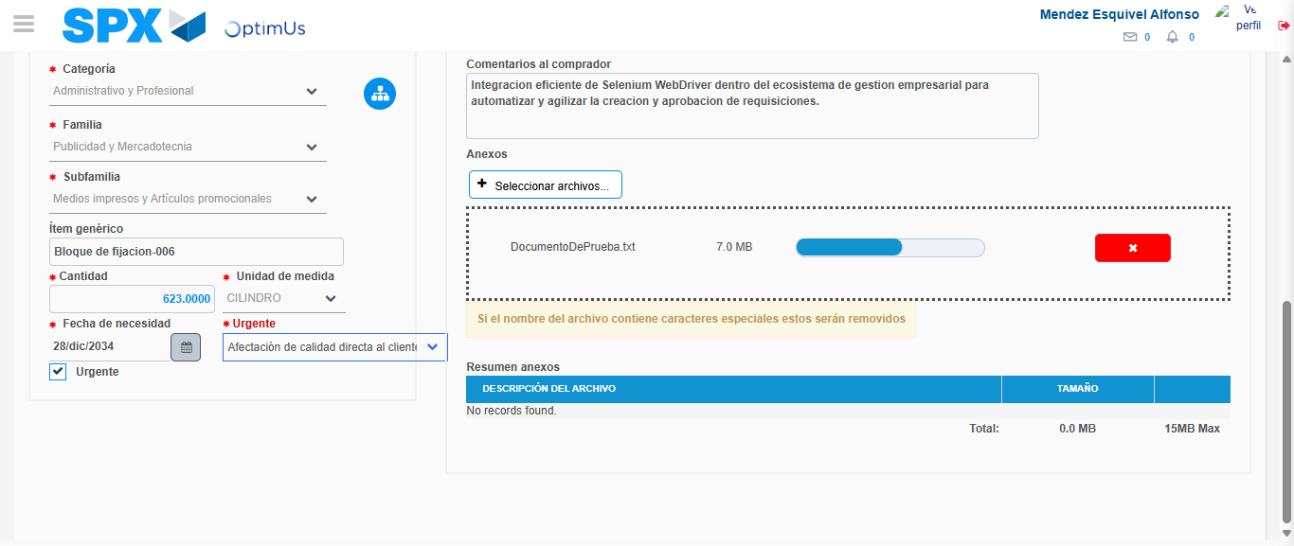Image file-name: QC_Testing-tc006_SPX_Dev5_Crear_Requisicion_Spot_Tipo_Cobro_Proyect_Urgent-1783376638224

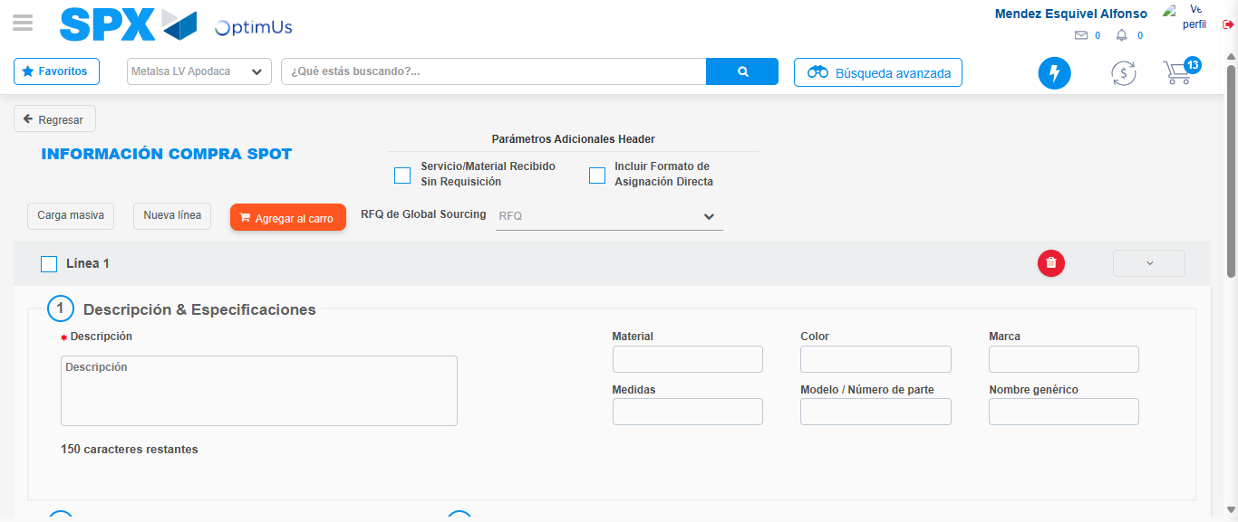Image file-name: QC_Testing-tc006_SPX_Dev5_Crear_Requisicion_Spot_Tipo_Cobro_Proyect_Urgent-1783376639655

Step 7 - Return to Main Page SPX : Return to Main Page SPX
Image file-name: QC_Testing-tc006_SPX_Dev5_Crear_Requisicion_Spot_Tipo_Cobro_Proyect_Urgent-1783376603058

Image file-name: QC_Testing-tc006_SPX_Dev5_Crear_Requisicion_Spot_Tipo_Cobro_Proyect_Urgent-1783376605588

Image file-name: QC_Testing-tc006_SPX_Dev5_Crear_Requisicion_Spot_Tipo_Cobro_Proyect_Urgent-1783376622472

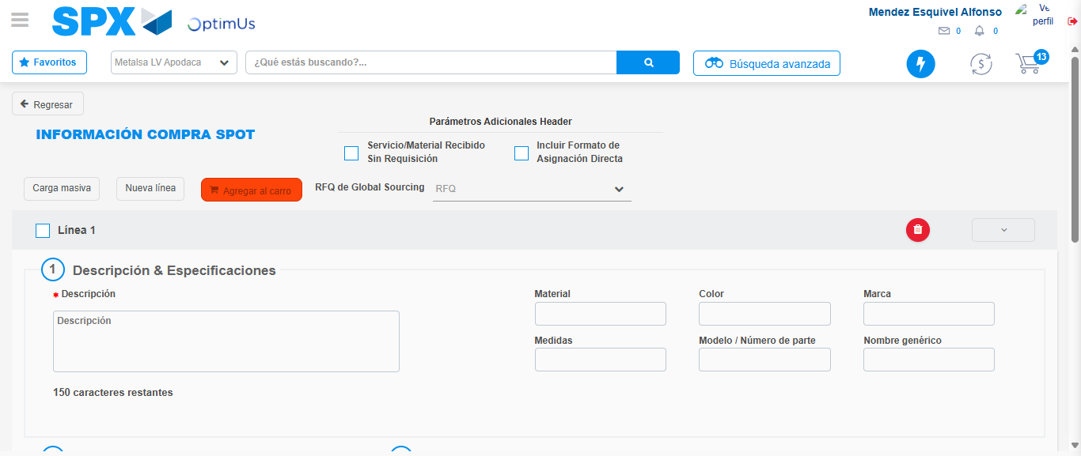Image file-name: QC_Testing-tc006_SPX_Dev5_Crear_Requisicion_Spot_Tipo_Cobro_Proyect_Urgent-1783376641896

Image file-name: QC_Testing-tc006_SPX_Dev5_Crear_Requisicion_Spot_Tipo_Cobro_Proyect_Urgent-1783376642082

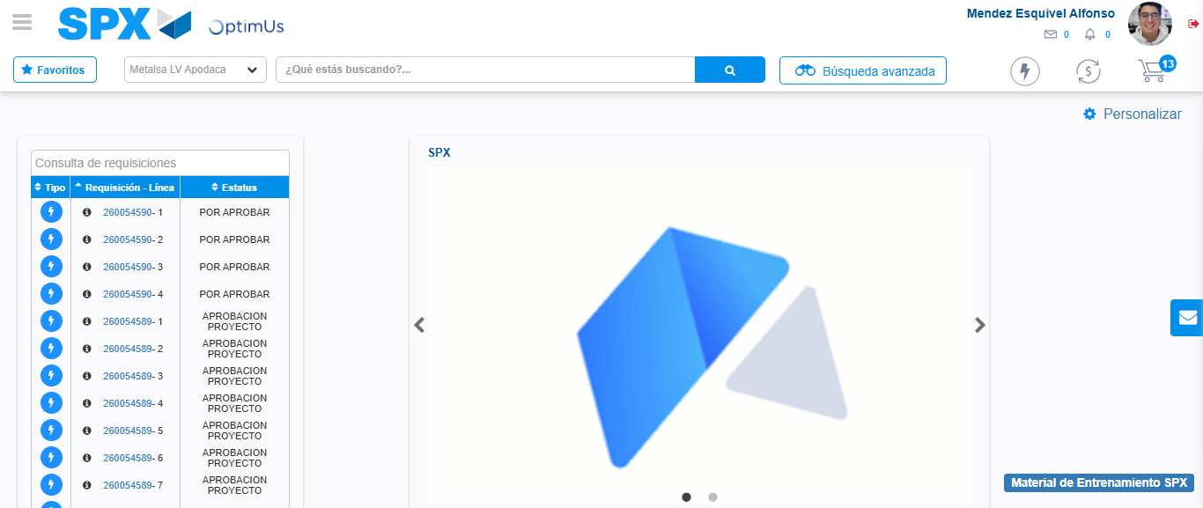Image file-name: QC_Testing-tc006_SPX_Dev5_Crear_Requisicion_Spot_Tipo_Cobro_Proyect_Urgent-1783376663259

Step 8 - Log Out : Log Out SPX
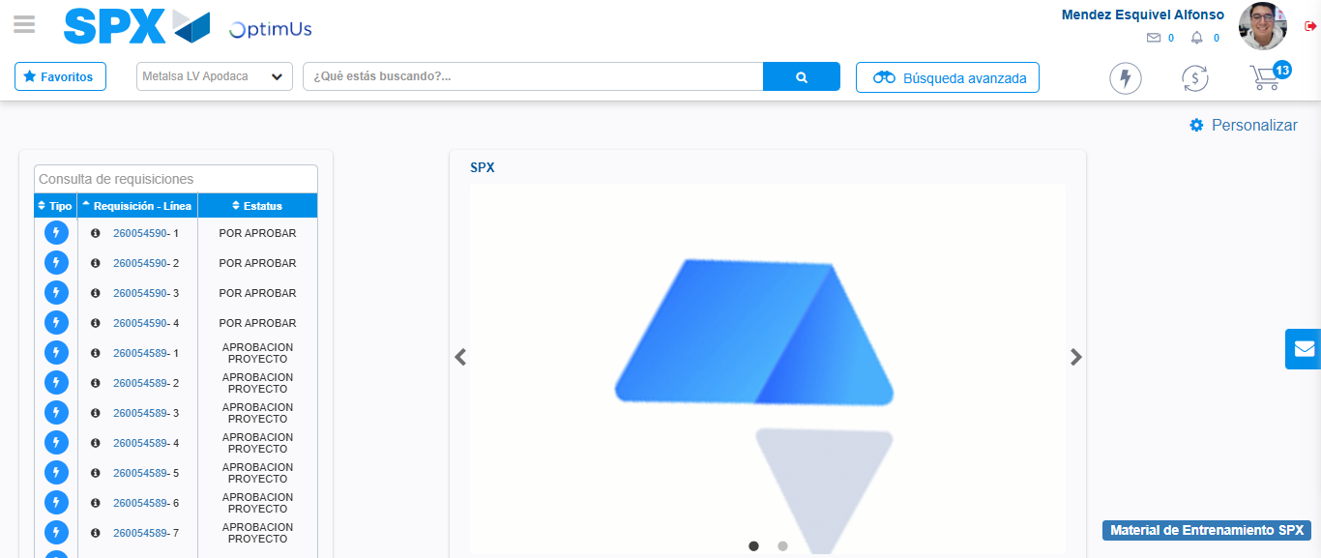Image file-name: QC_Testing-tc006_SPX_Dev5_Crear_Requisicion_Spot_Tipo_Cobro_Proyect_Urgent-1783376663518

